West Hull Ladies
RRC

October Newsletter

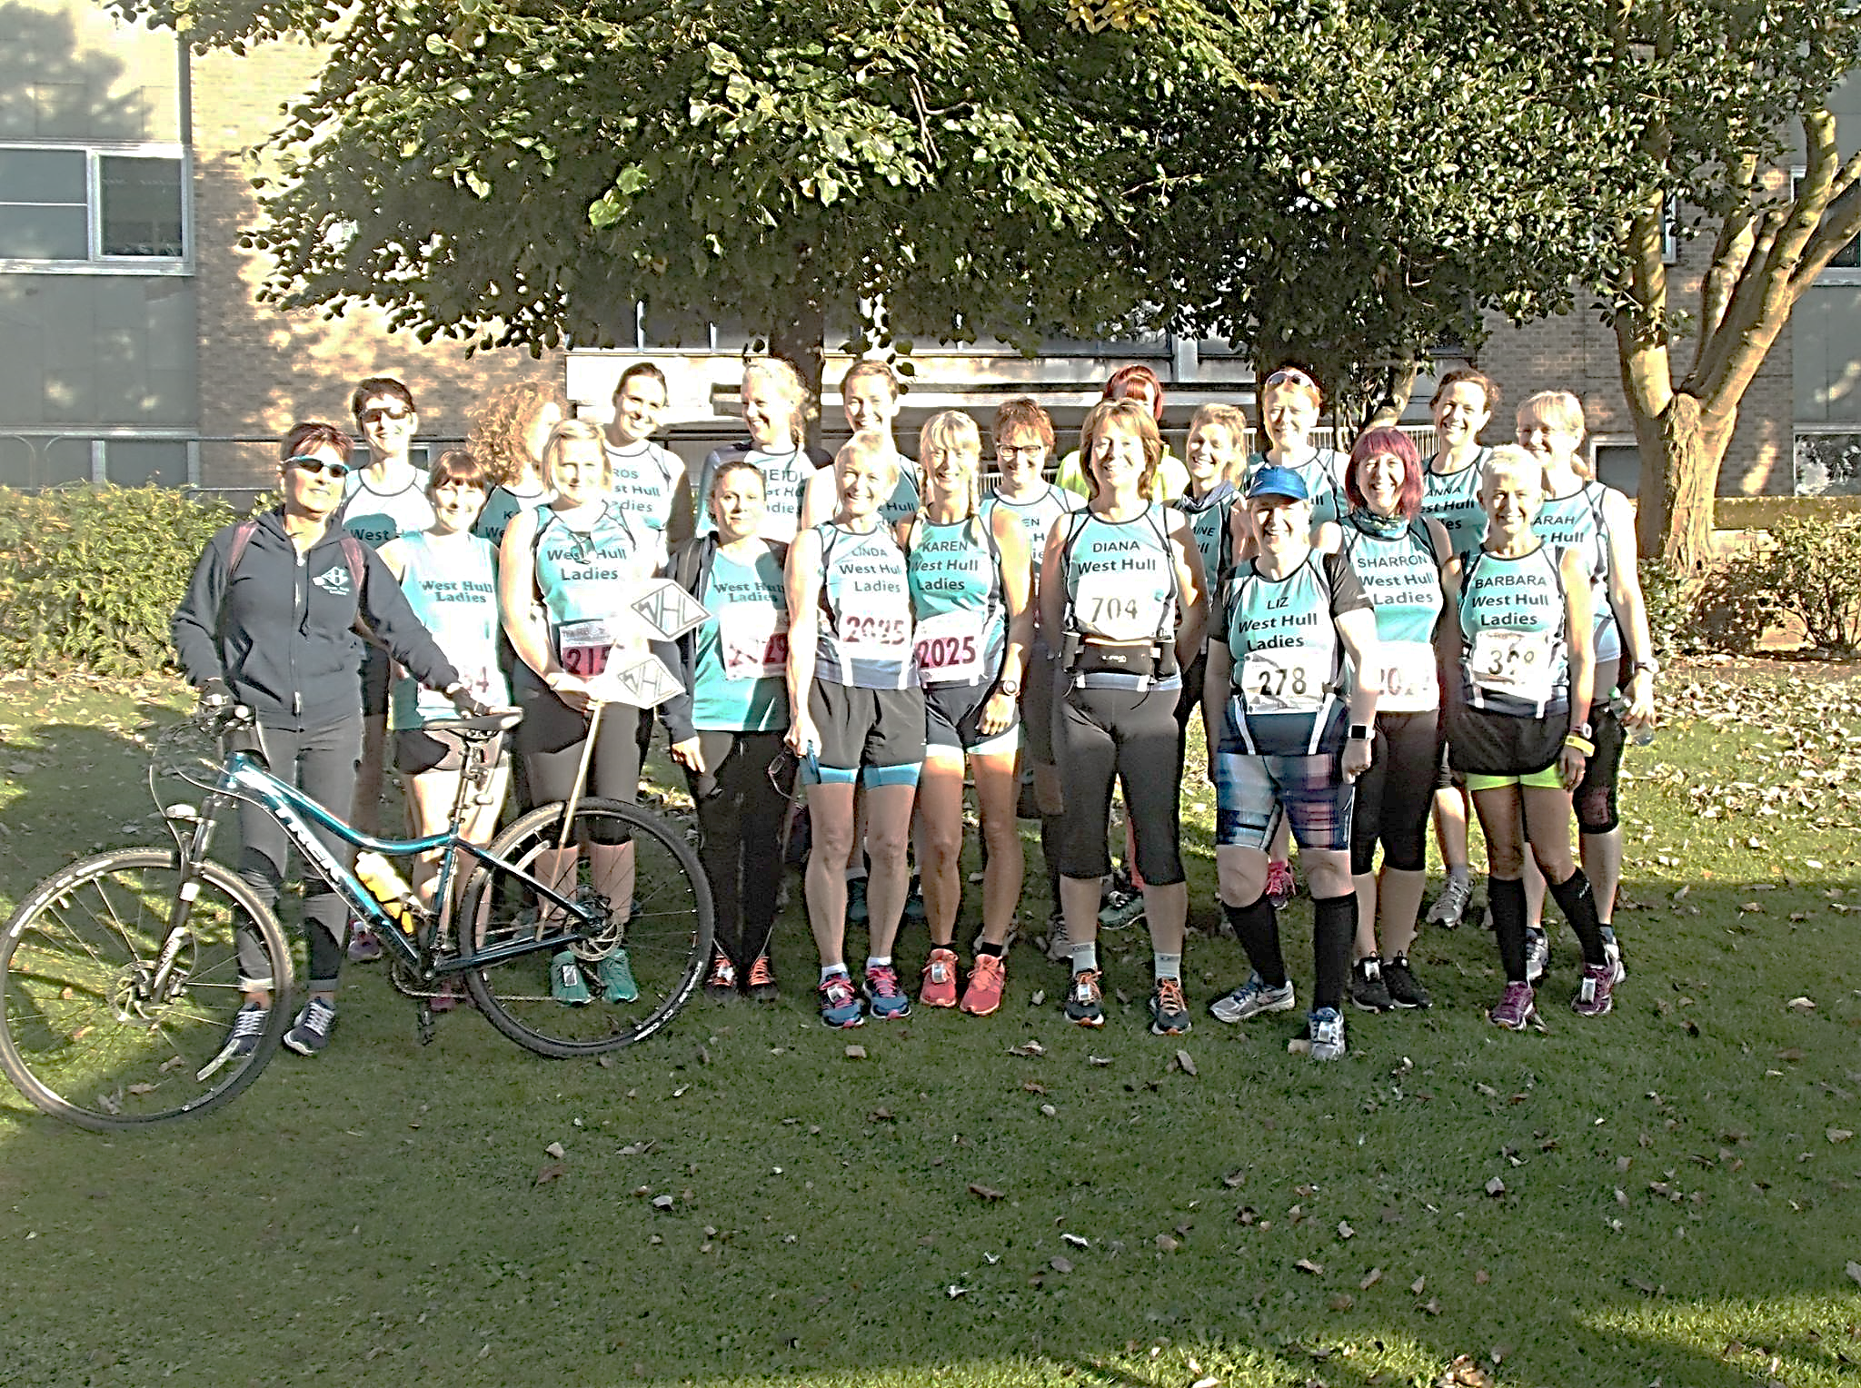

Hull Marathon 2016
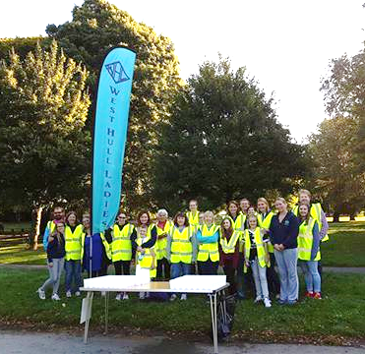
West Hull Ladies
Committee Meeting Minutes

3rd October 2016
Present Liz, Shelley, Linda, Amanda, Sandra, Maria, Jan

1. Apologies received from Jill, Anna, Karen S, Annette
2. Minutes accepted as true record
3. All matters arising had been dealt with.
4. Hull Marathon - once again excellent. Ladies thanked for all their help at the bagging, water station and marshalling.
5. Tired of being Tired - this seminar to take place after training on 17th October. Ladies who had not informed Amanda they were attending were encouraged to do so. Amanda to confirm room booking.
6. 0-5k short discussion about whether this should go ahead. Agreed it should and it would be further discussed at November meeting. Sandra informed the group that Carol Holmes had offered to be involved with the setting up of a run/walk group within the Club. The committee thought this was a good idea. Sandra to discuss with Carol to see how this could be progressed.
7. Amanda gave her thoughts on catering when we have a club visit to Dalby Forest. Agreed that Ladies should cater individually for the Friday evening but on the Saturday each pod should provide one course for everyone. Example one pod to prepare starter for everyone, one to do mains etc. Amanda to continue this with members attending.
8. Sandra informed the group about the discount offered by sportsshoes.com to WHL. They would give us a new code every month but they stated that this was not to be given to anyone else and could not be circulated on Social media. If we did this we would lose the discount of 10% and free delivery.
9. Christmas Social. A discussion took place and it was agreed for Shelley to contact Hitchcock’s restaurant and if possible book on a suitable date.
10. Amanda stated CofHull were happy for some members to join the Winter League. Also stated email received from Karen Scott stating that we had 79 members - the most we had ever had. Due to work and other commitments Karen also stated that she was standing down from being an administrator for our Facebook page. She may have to reassess whether she can continue her role as membership secretary. Everyone expressed thanks to Karen and hoped that she continued in this role because of the excellent work she did. Linda stated how they worked well as a team when memberships had to be renewed and what a loss it would be if she did not continue. Amanda to reply to Karen expressing our thanks for all she did.

There's no Meet a Member this month, but I would like to announce that we currently have:
79 members!!

I think that it’s worth celebrating!

Invitation to run from Dalton Holme Village Hall, South Dalton
6-8 miles road
Thursday 27th October (half term).
Meet 9am Skidby Mill for car shares or 9:15am outside the village hall:
Amanda & Sandra

How to find it: Get to South Dalton, follow the signs for the Pipe and Glass. It’s on the right before you reach the Pipe and Glass (just after the turn off the main road).

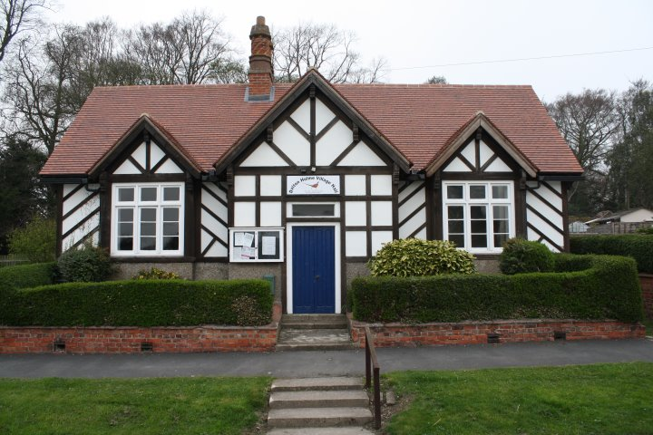
Randomly found this little treasure whilst we were on a cycle ride. It said ‘Coffee Morning’ on the sign so we went in (well, we had cycled 15 miles so I am sure it was needed).
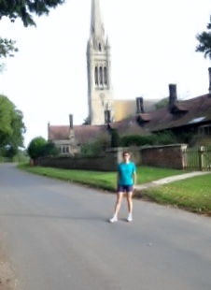
Some very friendly ladies waited on us. It is open every Thursday 10am to 12noon and costs £1 for a cuppa and slice of cake.

The planned run is on quiet undulating roads like these:

With tea and cake is like this

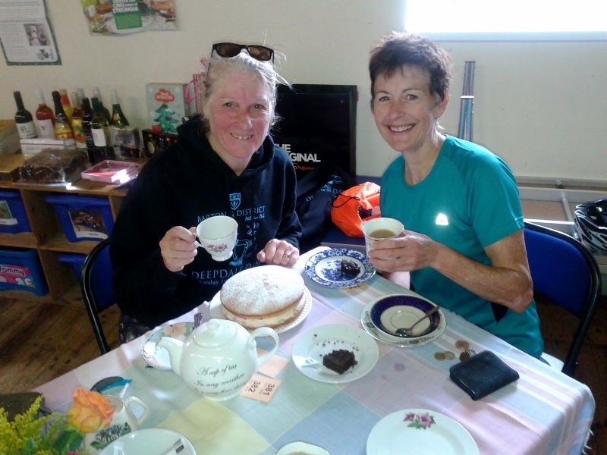

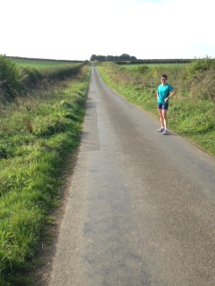

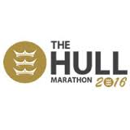
A Summary by Linda

So today was the Hull Marathon and so many of us took part. 11 of us wonderful WHL entered the whole marathon and then there were 5 pairs and some 4's in a relay. I think I counted 35 entries when I looked at the list before I came out on Sunday morning.
I am not going to copy and paste everyone's comments like I usually do as there are way too many. Almost all of us can see the posts on Facebook, there are also loads of wonderful (and not so wonderful (me)) photo's posted too, in fact every time I turn my back some more are posted up, I just can't keep up! I will just say a piece about the wonderful day we had with WHL.
This is something we do well, get together as a huge group and enjoy an event, helping and encouraging each other in any way we can, laughing and crying together is also something we do well! Today was no exception. I would like to thank all our volunteers and there were quite a few of you, I didn't get to see you at the water station but I know you were all fab.
The WHL supporters out on the course in various places shouting and yelling our names, geeing us along wherever we were, you are all awesome. A very special thank you to our very own WHL cyclist supporter who has just come out of hospital and couldn't run her half leg herself, the wonderful awesome Tracy. I have to mention Kate Nicholson and her beautiful daughter Esmae who I met for the first time at mile 20, she desperately wanted to get a high 5 but I couldn't help it, I scooped her up and gave her the biggest hug and kiss before putting her down and then giving a high 5 before I carried on my way, very special. The wonderful Sandra who followed us on FB even though she was hundreds of miles away in California (lucky her), in fact I think she messaged Tracy to get her up on the top of Hessle Rd flyover to make sure none of us was walking (just like she did last year)!
The newer ladies who hadn't yet experienced such a big event and who were able to take part in a marathon and join in the WHL fun (well I hope it was fun ladies and you'll repeat the experience). I think I remember Amanda mentioning to Caroline just how far she'd come from her first run with us this year. Carol who brought in her relay team as the last runner, what a wonderful lady you are and so determined.
Commiserations to Ann who 'broke down' but had the sense to go home and not injure herself further. She is a total star. To Diana W who was using this race as her training run for her marathon which is in York next month, she managed a half in the heat. Oh boy that heat!!
To each and everyone of you that made this day perfect, for helping us get through the miles no matter how far we actually ran to be part of this WHL experience. THANK YOU.
Ok I'm going now before I cover my keyboard in tears, you are all fabulous, every single one of you.
Linda xx

At the bridge, work done. Waiting for the bus to Hull
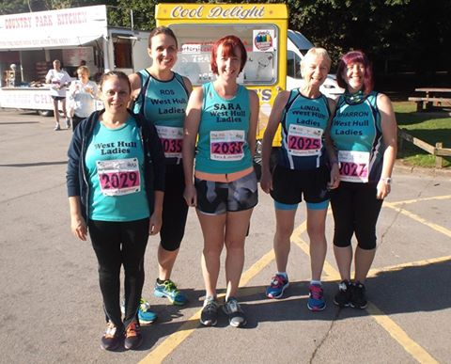

Hull Marathon Relay: Sian
Team Elles Bells
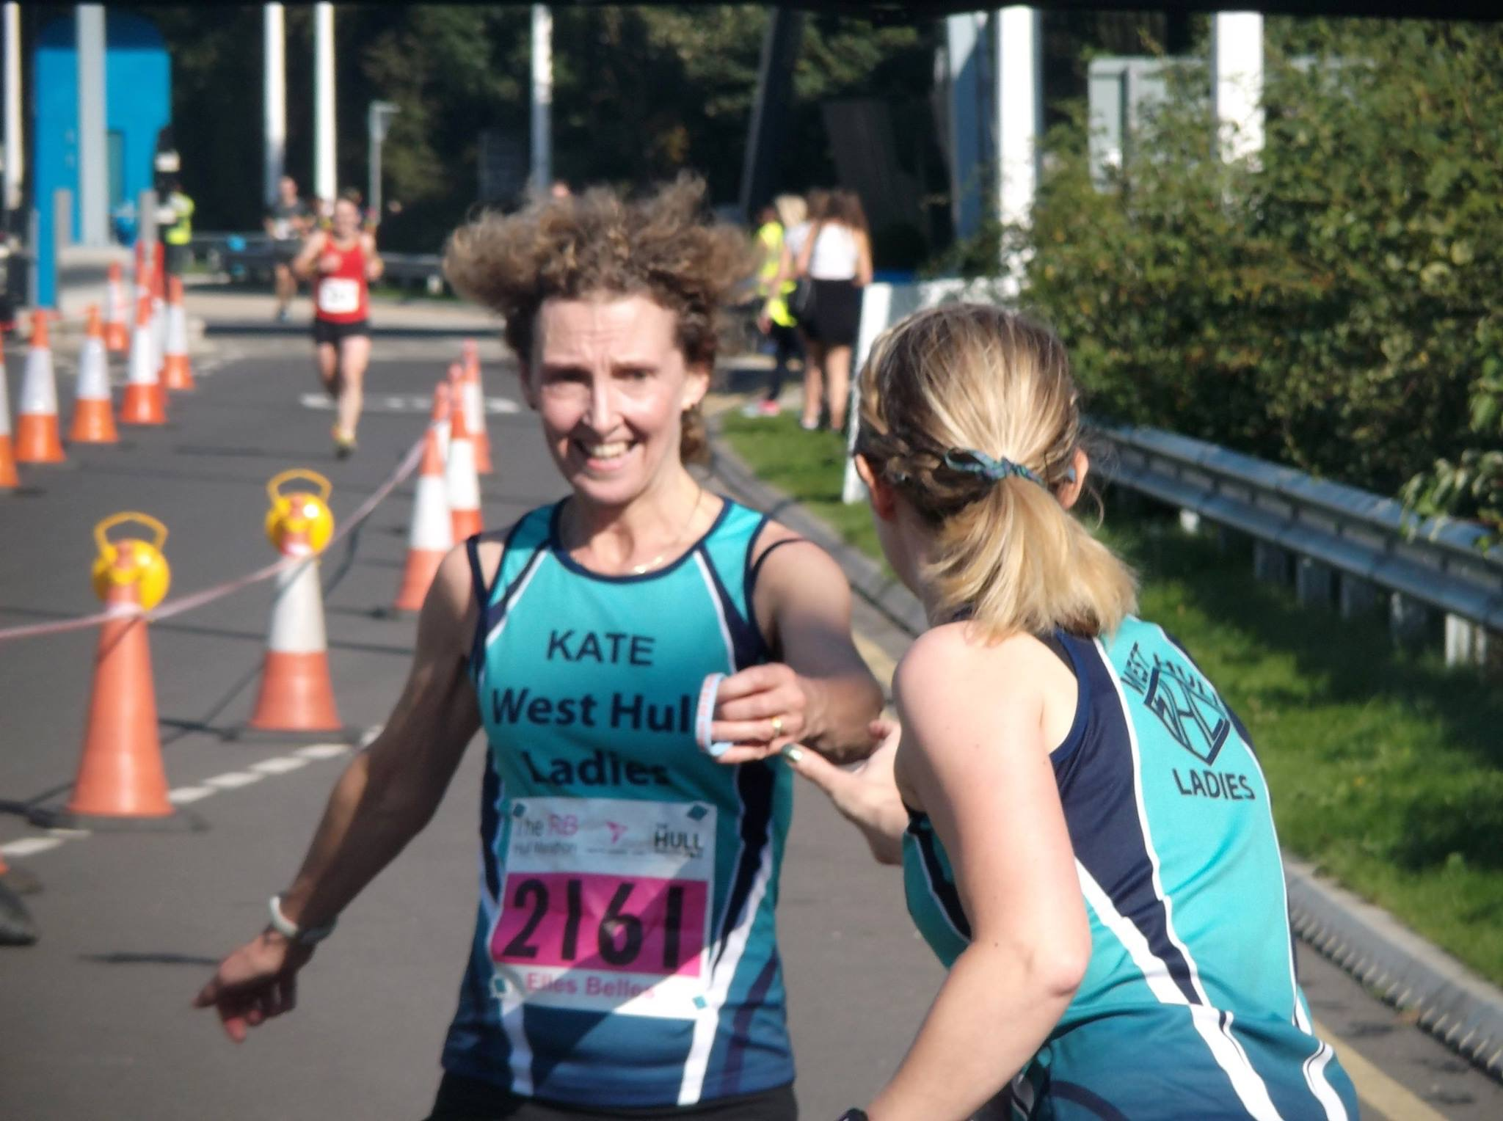
I was really nervous about the marathon. The logistics of it all scared me - would I arrive in time? Would I know what to do at the relay changeover? Would I be totally rubbish? etc. My father-in-law gave me a lift to my starting point at the Humber Bridge, but bless him couldn't find a safe place to stop and ended up having to drive across the Bridge and back (paying the tolls both ways!).
I was so relieved to see the kind faces of Sharron, Ros et al waiting there. They were full of useful advice and support as always, and even sympathised when I ran off to pee for the millionth time. When my number was called I was so impressed at how speedy my team mate Kate Bowers was - she was powering along the Bridge giving the traffic a run for its money! We did the handover without incident and I was off. I couldn't believe it - I was running in a marathon!
I had a stupid grin on my face, waving at every passerby and giving lots of high fives. The view from the Bridge was breath-taking and at that point I was basking in the sunny conditions (I changed my mind later!). The next section, the out and back on the Lincolnshire side of the Humber felt like a strange addition - maybe to add some miles? At least it gave me a chance to see my husband Rob and give him and a couple of other familiar runners a hello and a high five on the way past.
It was baking hot by this time though and although Ros and I refused the water initially round, I grabbed a bottle on my way back up to the Bridge. Running back towards the north bank was harder - the hot weather and lack of support on this side of the carriageway made it feel a lot longer but I kept myself going with the promise of a jelly baby from my stash when I reached the end. Just the one though. I had promised myself to take it steady across the Bridge and managed to do so, hopefully to give it some welly on the last stretch downhill.
The support in the Humber Bridge car park was immense, with one elderly chap stopping me to give me a hug and lots cheers and applause. And it just kept getting better. Running through Hessle, past families holding out jelly babies, kids giving high fives and everyone shouting my name and telling me how awesome I was - I felt like a celebrity on the red carpet! In Hessle Square I was moved to tears by everyone’s goodwill and the atmosphere. But as I Ieft Hessle and the crowds thinned, I started to lose my buzz. The heat combined with being unable to judge how far I had left, sapped my energy and I didn't finish as strongly as I had hoped. I managed 1:06:14 which was a couple of minutes off what I'd wanted, and I was over the moon to hand over to Heidi and stop running!
As I was leaving Pickering Park I saw my husband Rob again. He looked in bad shape and I helped him off to one side to stretch out cramp in both legs. I felt awful leaving him but he wanted to soldier on and finish the full marathon. After a very long wait and an even longer bus journey on the relay shuttle, I finally got into the city centre to check on Rob and cheer my fellow WHL as they crossed the finish line. What a group of heroes they all were too. From the brilliant Jill Jameson who won a prize for her stunning time, to the absolute elation of Shelley and Stacy as they crossed the line hand in hand, I have never been more proud to be part of a group. I immediately decided I want to run the whole marathon in 2017. And you guys are the reason. You've inspired me, trained me, supported me and taught me so much - thanks for everything WHL.
Sian xxx
Hull Marathon: Barbara

It was a truly amazing day and although it wasn't how I'd planned my run to go......the support and encouragement meant more to me than you'll ever know xx 😢
I was so very proud to be a whl on that day (every day really!!!) Special thanks to Amanda for getting me through that last bit. I really did struggle in the heat but I was super determined to finish!!!

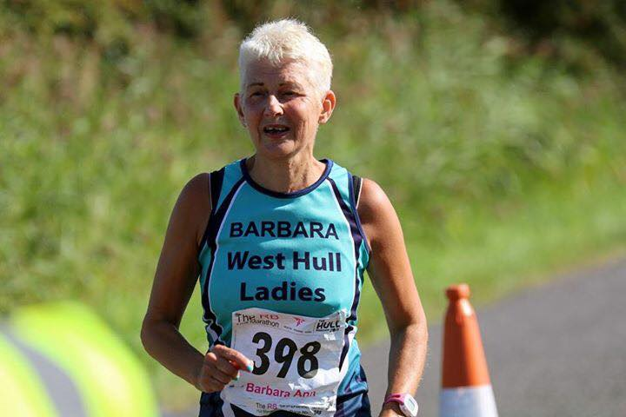
Hull Marathon Relay: Anna
Team Whisky and Chaser

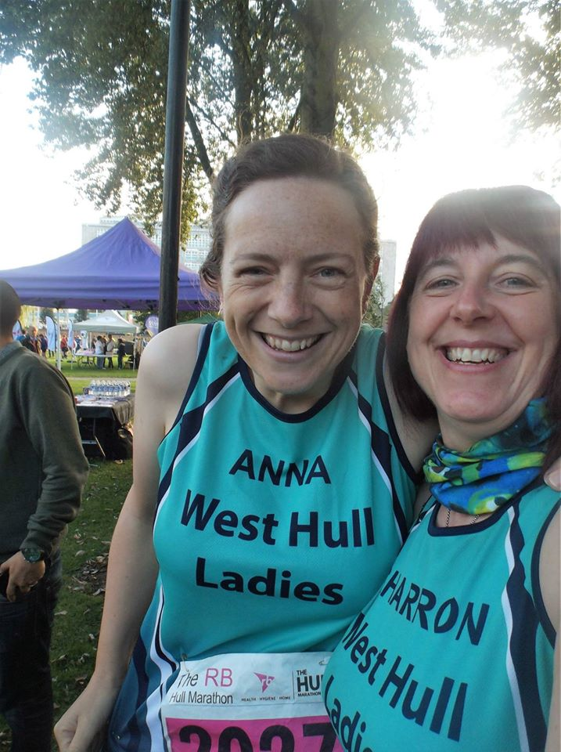

So, basking in the success of my first ever half at North Lincs- which I had loved doing, this seemed like not such a crazy idea. When Sharron offered to do half a relay team, I thought "why not". We both knew that we would not be as organised with our training this time round. Sharron was away just before the race, and I hate training in summer- there's no routine, it’s too hot, I end up with a beer in the garden which ruins the chance to be out with club later- but we both had a pact of "time doesn't matter", and thought that we should just give it our best shot. I also remembered how much I had loved being part of the whole marathon day last year, and was certain that I wanted to do it again, and was looking forward to the whole day out as much as the running.
It was wonderful and reassuring as ever to all meet up in Queens Gardens. We waited nervously in the glorious weather, then were off. In my head this was two races- the first being up to the gorgeous East Park and back. It was so lovely to see Suzanne on the way out. We reached the park, and I was enjoying my run and found a comfortable pace. I had a strange feeling of being very far away and going to the wrong direction though- people running the whole thing into Lincolnshire must have really felt this- its a long way from East Hull to the bridge! There were lots of people out which was lovely. Although- they all kept joking and commenting- so I turned round to find out why- the joker was just behind me!
I ended up running a couple of miles with him- through town and to West Park. What a guy- he runs a marathon pretty much every weekend! Blimey! It was getting really warm now- but he was in full costume so I couldn't moan about it!
I don't find it easy to run with others in a race, which does make me sad- so at the Argyle street I let Joker and Sarah, who had run with us both since the handover in town, go on ahead. Someone else has mentioned the fact that we managed to go over TWO railway bridges to get to West park- that's two too many. They were hard going.
I was so looking forward to seeing our water station- the thought of it was getting me round, and it was so lovely to be welcomed into the park by Rachel W and Jill C. I had a lovely water and a chat, then was off. That was the next milestone done.
Anlaby road didn't seem as much of a slog as I had been expecting. My knee started to play up a bit, so I had to stretch it out a bit. I ended up playing catch with the 5 hour pacers, they would go ahead while I sorted my leg out, then catch them up. They were kindly checking on me each time which was sweet.
Then dreaded Boothferry road hill appeared. At Darley's roundabout we came across White City's water station, where someone who sometimes joins us for a run (sorry I dont know her name!) was handing out water with her son- AKA Captain America, who was being a true super hero and sorted me out some water. I also went for another jelly baby, although I was getting a it sick of these at that point. They start to do weird gelatinous things in your mouth after a while! I imagine jells do this too. Very odd and not pleasant!
The hill of Boothferry road itself- well- I managed about two thirds, then I just gave up and walked. I'm cross at myself, as another runner had been giving me a real boost- encouraging me up it, and I let her down. I knew I only had half a mile to go- so I really should have carried on. How you guys doing the whole thing managed this I have no idea!
At the top I got to the bridge and managed to speed to the gang- what a welcome sight you were! I gave my team mate a massive hug, wished her luck, then flopped on the grass, and waved other runners coming through. We then staggered off to find the bus. I think that managing to get upstairs on that bus earned me a second medal- I felt dreadful!
Once in town, I found a coffee in Queens gardens that made me feel human again, and a group of us stayed at the finish line watching all of our wonderful club come through. This was my favourite part of the day- it was such a proud feeling, and quite teary at points. I am in awe of you all!! However far you ran, and however you contributed- it made such a fantastic day. And thanks to Rachel A and her daughter- as I kept seeing them, often at points where I needed a boost- it was lovely.
There was a big roast dinner waiting for me at home and a painful but essential bath!
Thank you chaser! I deserved my whisky that night!!

Hull Marathon: Lynne
Marathon Write up:
1. Run a marathon
2. Hate most of it
3. Swear never doing it again
4. .............You know what's coming don't you........???

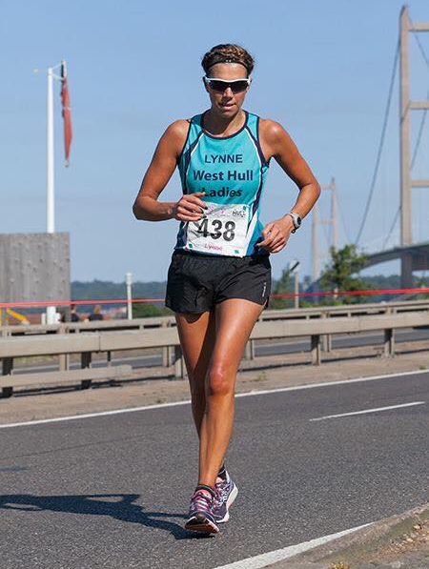

Hull Marathon: Liz H
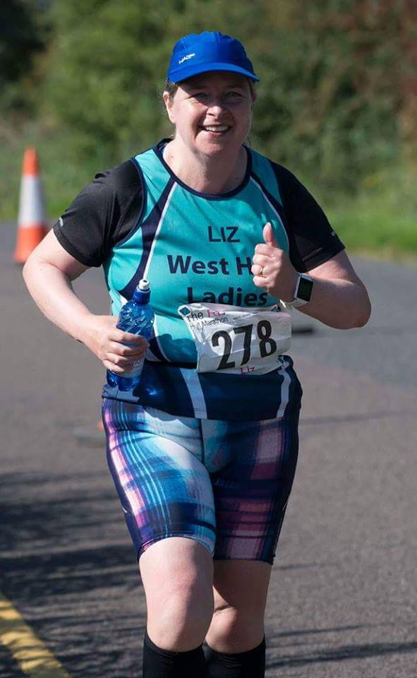
Once upon a time at least 20 years ago, while watching the London Marathon, I mentioned that one day I would like to run a marathon. Chris, my husband,
replied:
“If you run a marathon I will run bare arsed down Whitefriargate on a Saturday afternoon!”
In the years that followed, Chris was never in any danger as I was a confirmed couch potato. However, in 2013, he got diabetes and between the two of us we
decided to try to get a little fitter. This included me taking up running and Chris taking up triathlons and (actually vice versa but that's another story!).
So there I was, feeling quite nervous, waiting for the marathon to start. I was reasonably confident, having trained up to 18 miles or so, but also worried as
even proper runners, like Jill, tell me marathons are tough and will hurt. As always, it was great to see all my West Hull Lady “sisters” at the start, some of whom were doing the whole thing and some relay runners. There was lots of activity in Queens Gardens and it had a carnival atmosphere.
There was the usual queue for the toilets, I think I went at least twice but at long last we were off. In order to cope with the mileage I had tried to break up the
marathon. Basically you are looking at 4 x 10,000ms and a short park run. This to me makes it manageable!
The first 10k runs from town centre to East Park and then back Via James Reckitt. I ran along and chatted with Sarah from Beverley AC about the Champagne
League and saw Suzanne, who was marshalling the race down Holderness Road. I also spotted a new carpet shop down Witham!
I made reasonable time but suffered from the indignity of being passed by a man in an “Orville” costume although I did manage to keep ahead of the man in
army gear and a full military back pack on! I returned into town feeling happy that I was about on schedule and remembered to have a gel. I found Sharon, who is an old school friend, and was marshalling and we had a good chat and a hug, I was feeling good.
The next 10000m included the West Hull Ladies Drinks station, I was slightly miffed as you have to go over Park street flyover and Argyle Street flyover. I was
not entirely sure why you needed to cross the railway line twice! However, you then go into West park and run round to KC stadium where our lovely WHL
were. I needed the loo and was a little perturbed that the two gents in front of me had the same thought. Can you believe that when I was with a handful of
people at the back of the pack I still had to queue!?! I had a slight underwear malfunction, (I am prone to those!) managing to stick my fingernail through my
expensive, but very comfortable, Runderwear knickers. They now have a hole in them but I intend to keep them as a badge of honour! I then went through
the WHL drinks station with Zoe, making sure I got my energy drink. People were handing me maltesers and more water. All in all it was a bit like a formula one
pit stop with my very own pit crew.
A few miles after this highlight, I had my one and only low. I really struggled with Boothferry road, which is a gradual hill, it just seemed to go on forever. I was
OK where there were supporters, including one of my work friends, Colleen, giving me a cheer. But toward the end bit there was little support and my mind
played a trick on me, I saw what I thought was the 13mile sign, but it was actually the 11 mile sign. There is a massive difference psychologically because 13
miles means you are nearly passed halfway. I had a real crisis at that point, physically I wasn't too bad although I did start walking up the hill and felt a bit
dizzy. I was also really worried about the hill up to the Humber bridge because I was thinking that we would have to do our normal “Hill Climb”to cross the
bridge. The guy behind me was very supportive and I resorted to my one step at a time adage, “with every step you are closer to the finish”, keep it simple
“one step at a time”. This stopped me from stressing and also people on the route where handing me water and jelly babies which cheered me up.
The biggest boost came when I realised that as we were running on the road there wasn't really a hill to get on the bridge. There were also WHL relay runners
at the top. Amanda pushed a bottle of water in my hand and told me to keep going. It was probably the best bottle of water I have had as I think Amanda
had magically put some of her running power into that water. I was passed halfway and was feeling epic.
The bridge was hot but I had my magic water and actually began to catch some of the other runners. There was one lad who was suffering who I told to keep going. I heard someone shouting my name from the other side of the bridge and saw Jill frantically waving at me. She looked really strong and I think I looked good too. I realised I could actually see other WHLs and this helped too as I was spotting them and waving. As I got over the bridge, I poured the last of my water over my head before having a banana and another drink at the water station.
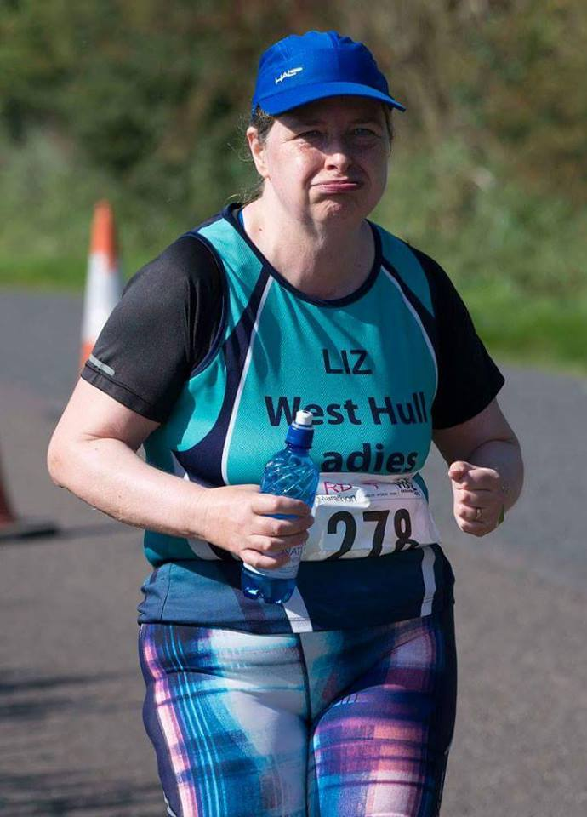
Then I set off towards Barton which of course was the wrong direction! Luckily the marshals spotted this and sent me the correct way! (Honestly if I had a brain I would be dangerous!) I managed to catch up to Barbara because she had, had to sit down as she was feeling dizzy. I was quite worried about her but she had a marshal with her and Barbara told me to leave her and that she would be OK.
When I got to Hessle I saw Sarah King and we had a bit of a hug before I set off again, I told her about Barbara as I knew she would look out for her. The people of Hessle were great, there was clapping and cheering; more extra water and more jellybabies; a lovely obliging couple with a hosepipe, just bliss! I was
now walking and running. I spotted Suzanne, who sort of spontaneously appeared at Sirius Academy she walked with me to the entrance to the school and got me running again. It was lovely to see Karen and Liz just coming out of the school as I ran round the academy before seeing Suzanne again. I just had a long parkrun to go, I could crawl it, if I needed to!
Despite having a few blisters and suffering a little, I enjoyed the last bit. I saw Hannah's old headmistress Katriona, who is a Beverley AC member and she looked quite impressed that I had got this far. I walked up the Anlaby Road flyover and then it was the docks.
In the distance I saw Amanda and Zoe who had come to find me. I was very pleased to see them particularly as Zoe had water and also took my running pouch off me, which had seemed to have got heavier even though I had been consuming my gels all through the race. Amanda went to make sure Barbara was OK and Zoe “ponied” me back. I was determined that I would run the last mile and that was exactly what I did do. Zoe ran with me and I saw Sharon who had decided to volunteer to marshal at the end which was ace. As I ran into the finish I saw, Cath who I used to work with and is a Fit mum, more West Hull Ladies and best of all Jill cheering me in.
I had done it! 5 hours 43mins 28 secs!
It wasn't quick, it wasn't pretty but I did it!
57776 steps!
PS Chris was there at the finish he told me how proud he was of me, although he was looking a bit worried

Hull Marathon: Linda

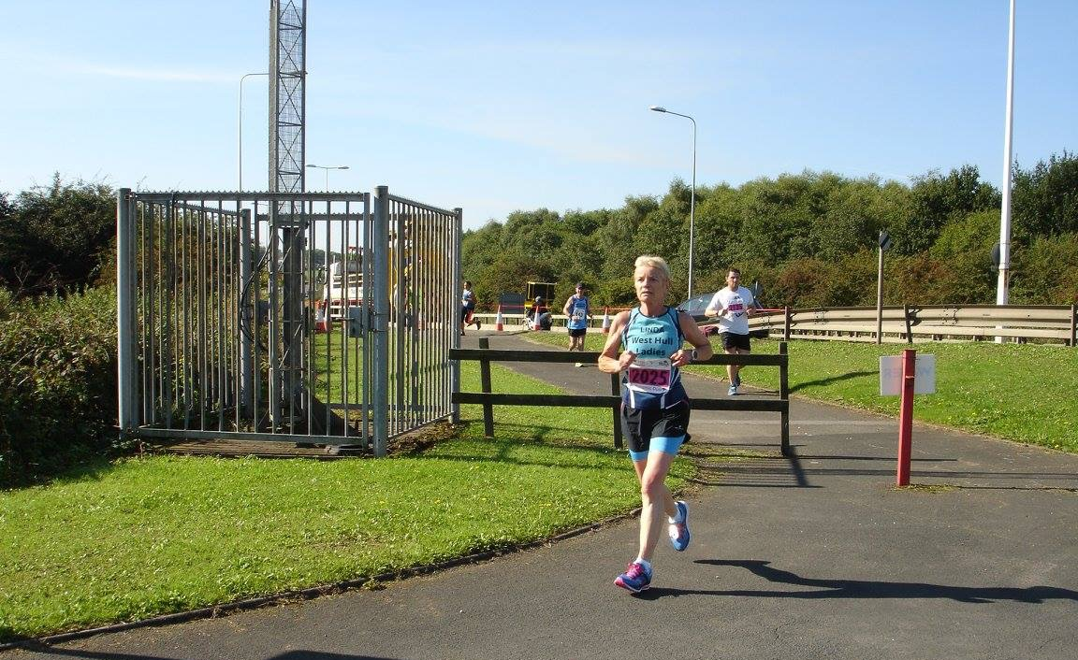

I was going to be a little goodie two shoes this year and help at the WHL water station, that was awesome when I ran by last year I really wanted to cheer on all our ladies and have a fun morning. Well that was until a post came up on our FB page from Karen Park who was seeking a partner to run a half each. Well she’s dead fast girls so I waited for someone to reply, someone with speedy legs but no-one came forward so I put my name forward saying that I would be her partner if she wanted but that if someone faster came along they could take that place. And guess what ladies, she took me up on it ..........the pressure was on!
I trained (I think) and before long the morning arrived and boy was I nervous, I didn’t want to show her up or let her down.
Sara Ellis and I decided to leave a car in town and drive a car to the Humber Bridge. It was great being at the start to see everyone and I wasn’t nervous, well I didn’t have to start running for ages yet, it didn’t actually feel real. There were so many WHL there, relay teams of 4, relay teams of 2 and a fair few of you brave souls running the whole distance. You are all amazing. The atmosphere was fantastic and it was great to see everyone off at the start.
We made our way back to the car park and managed to get Ros, Sara, Maria, Diane and me, yes we did manage to all squeeze into my little car! And away we went chattering away to the Humber Bridge. What a lovely atmosphere on there it was too, it was great to see the top runners run by and they even acknowledged us in fact they didn’t even look like they were running (how on earth do they do that – we did try to copy)!
Finally things started to get going and get serious, before long Amanda came in and passed over to Ros and a few minutes later I saw Karen coming in and at last I could get going, it seemed such a long time since I’d left home this morning!
It was a glorious day, I loved running over the bridge and even back again (which I normally hate on the Humber Bridge half)! I was really enjoying the atmosphere and the sun but after around mile 9 even I was too hot and hungry, boy was I hungry. It was strange passing the mile markers knowing that I hadn’t actually done that many, it was a bit difficult keeping tabs on exactly how far I had run I was beginning to become confused (doesn’t take long)!! I was thinking about our ladies that were running the whole thing and wondering how they were, especially my lovely WHL sister Liz H and my WHL daughter Liz D.
Finally I was approaching the docks and low and behold a water station that had some fruit, I was famished so managed to eat some banana and drink a whole cup of water, now that I was feeling better I was able to pick myself up and start running towards the finish although it was still over 2 miles away (that Liz, is a long way)! There was the bell ringing letting me know there was only one mile to go (as if I needed reminding), then those horrid cobbles and finally the 800m sign (that’s only twice round the track) – still a long way! Then the 400m and finally I could see the finish line, thank goodness. I had been thinking only the day before that I wished I was running the whole way but I was so glad that it was only a half in the end, that sure was far enough.
I was so proud of our WHL today, the runners, the marshals and our very own water station ladies (and families) that helped on the day. Plus our lovely evening of goodie bag packing the previous Thursday night. This is something we do so well as a group.
Thanks to Karen for being my partner and sorry I wasn’t as fast as you, but we didn’t do bad at all, we came second ladies duo how cool is that, competing in a marathon and being second, absolutely amazing, but not quite as amazing as our wonderful Jill who came first in her age group.
Well done to each and every one of you, you are all awesome.
Hull Marathon: Stacy

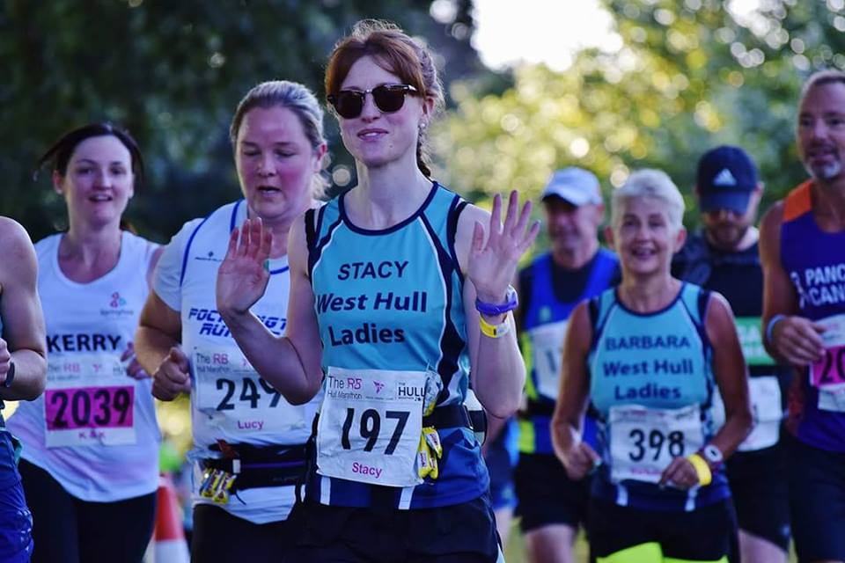
Hull Marathon: Shelley

4pm Sunday 18th September 2016 – I’d better write this whilst it’s still fresh in my mind …
The start - the atmosphere before the race was amazing, the music was on and I saw so many people that I knew; random friends, the Sunday marathon group and of course the mighty WHL, however it nearly all went wrong before it began as the portaloos had me retching, gross!
Anyway, I got over it and started the race with a group of WHL and we pretty much stuck together for the first half of the race (Jill and Cath were off ahead!). As an East Hull girl born and bred, I loved seeing lots of people I knew out supporting in the crowds down Holderness road and in East Park, including my parents, who screamed like nutters. How embarrassing! In town I saw my colleagues, who were marshalling, but the best supporters were at the WHL water station, where I had another portaloo incident – this time my sunglasses steamed up inside and I had knicker issues, how you can lose them without taking them off I’ll never know. Andrea was waving my healthily stocked picnic bag at me, but I pretty much ignored it and ate most of the Malteasers, cheers for those ladies!
Boothferry Road – I was sick of the sight of that bloody hill after running up it most Sunday mornings in training, but I was determined to run all the way up it without stopping, so I did! The food and the funny signs from the crowds helped “You still look really pretty” and “I love the smell of 4,000 runners in a morning” were my favourites.
13.1 – Half way. Stacy and I ended up running away from our WHL group at this point and were ready to take on the bridge (“that f*%^ing bridge” to quote Stacy). We saw lots of WHL, who were running back on the other side and we shouted and waved at you all, I was so proud at how well you were all doing. I was still enjoying myself at this point – but this was soon to end in Hessle, when the pain really kicked in.
Mile 20 – my feet were throbbing, my knees felt like they had been smashed to pieces and still 10k to go. Stacy’s boyfriend Martin was doing a great job on the bike, encouraging us and bringing water and some kind soul in Hessle had a hose pipe out for us to run through.
Sirius – Sense of humour bypass here, I was not a happy runner.
The docks – we were both on the verge of tears at this point and the marathon angels were a bit thin on the ground. I asked Stacy if she’d ever do another marathon and I got sworn at. That was me told!
The town crier – a sight for sore legs, 1 mile to go. Jan Draper was back from Equinox and in the crowd at around 400m to go and this was the beginning of the end for me emotionally, the bottom lip started to wobble and as I ran over the line it all came out. Sian gave me a big hug and I cried tears of relief! My parents were at the line too but I couldn’t string a sentence together to explain how I felt, my face probably said it all though.
The real race angels for me (apart from the WHL of course), were the Hull Uni post-race massage team, who sorted out my cramped up glutes (yes I did get my bum out in Queen’s Gardens and I didn’t care!). I still can’t get my head around it now, a few hours later, but I’m a marathon runner, I’d only joined WHL to improve my parkrun time. You’re a bad influence you lot but I love you all xxx

Fundraising News: Kate N:

Weʼre trying to raise £3,000 to Help fund special needs equipment for our autistic daughter to make her and our life a little easier.
Esmae is my 5th child. She was diagnosed as autistic this year just before her 3rd birthday. She is non-verbal and has significant developmental delay.

Esmae suffers from many anxieties one being separation. Daily living is difficult and life with an autistic 3 year old like Esmae is hard. She doesn't sleep, she trashes her room causing potential injuries to herself. She has no sense of danger and puts herself at risk constantly. She needs to be watched 24 /7. She escapes from her car seat, regularly walks into the road and climbs everything especially window ledges. I just want to make our home her bedroom our transport a little safer and easier on her and us.

Special needs equipment is so expensive and we are not entitled to her financial help as we both work and earn money!! Ridiculous as it sounds financial help is based on income not your child's needs!

Esmae needs a safe space in her bedroom. She needs sleep suits she can't take off. She needs sensory equipment that calms her when separated from us and she needs a special car seat restraint. The cost of all these things will be over £5000.

I'm hoping to raise as much money as I can for her by doing runs next year and I hope you can all help me do that.
Thank you.
UPDATE...My challenge is set....
- 3 marathons
- 2 half marathons
- 1 10k all in 2017!
Kate ( Esmae's mum)

Here is a link to the just giving page:
https://www.justgiving.com/crowdfunding/Esmae

2016 RACE DIARY

Free 5K time trial every Saturday 9am:
Hull Parkrun Peter Pan Parkrun Humber Bridge parkrun

Double check dates, times and entry fees with the official website or the entry form. Zx Website contains all the links to the races: http://westhullladies.org.uk/races.htm

October 2016
 | 15th/11:00 | Gruesome Twosome Half Marathon | £20 UKA/£23 | Entry form | Postal entries only
 | 15th/10:30 | Gruesome Twosome 10K | £13 UKA/£16 | Entry form | Postal entries only
 | 16th/10:00 | Bridlington Half Marathon | £15.50 UKA/£17.50 | Entry form | Online entry
 | 30th/10:00 | Yorkshire Coast 10K | £15 UKA/£17 | Online entries only | Online entry opens 1st June, 7am
November 2016
 | 6th/TBC | Deep Dale Dash | £15 UKA/£17 | Online entries only | Online entry
 | 6th/10:30 | Guy Fawkes 10 Mile | £14 UKA/£16 | Online entries only | Online entry
 | 6th/09:30 | Leeds Abbey Dash | £22 UKA/£24 | Online entries only | Online entry opens in June
 | 13th/11:00 | Dalby Dash 10K | £13.70 UKA/£15.70 | Online entries only | Online entry

NOTE: Club Vests must be worn at any races you enter
under the West Hull Ladies running club name.

Kit Order Form

VESTS, HOODIES and BEANIE HATS are purchased direct from www.pbteamwear.co.uk
On website: click on Clubs, Athletics Club, West Hull Ladies RC
Pick your size, name you wish to have on the front and follow payment instructions

For all other purchases use this form.

FORENAME ___________________________________
SURNAME ___________________________________

SALE - tick what you require and circle your size Price
- OLD STYLE VEST SIZE 10 £15.00 £5.00 (great for training)
- LONG SLEEVED SIZE 12 14 £18.50 £10.00 (great for training)
NOTE: Only 2 vests remaining and only one of each size of long sleeved

- BEANIE HAT £6.50 whilst stocks last
- PINLESS WHL NUMBER FASTENERS (set of 4) £3.00

DATE Ordered _______________
AMOUNT PAID _______________

Please transfer payments online with your name and marked as ‘Kit’ to:
Account: 63762742 Sort Code: 20 43 49

Or cheque payable to ‘West Hull Ladies RRC’, and write your name and ‘Kit’ on the back and give to Club Treasurer Linda Dodsworth, 110 The Stray, South Cave, E Yorkshire. HU15 2AL

Sign on receipt of goods _________________________________
DATE _______________

Please complete this form and email to mariaediaz63@yahoo.com
Thanks.
Maria Kit Officer

